**Running Head**

*Vegetation and soil moisture under active fire regime*

**Title**

Forest vegetation change and surface hydrology following 48 years of managed wildfire

**Authors**

Jens T. Stevens 1*, 2 Other authors here, in whatever order: Ekaterina Rakhmatulina, Gabrielle Boisramé, Brandon Collins, Scott Stephens, Sally Thompson, others?

**Author Affiliations and Addresses**

1Department of;

2US Geological Survey

*Corresponding Author: Department of Plant Sciences, UC Davis, 1 Shields Ave, Davis, CA, 95616. E-mail: jtstevens@ucdavis.edu, Telephone: 530-752-5011.

**Abstract**

Something

**Introduction** (General outline to be filled in by co-authors)

Like much of the continental United States, the forests of California’s Sierra Nevada have experienced fire exclusion since the end of the 1800s, and were managed under an active policy of fire suppression throughout the Twentieth Century (McKelvey et al. 1996). The consequences of this fire exclusion for the vegetation of the Sierra Nevada are well known, including: increases in forested area, forest stem density and uniformity of stands, reductions in landscape heterogeneity, and suppressed reproduction of fire-mediated serotinus species (Collins et al. 2011). By creating large connected patches of dense fuels, fire exclusion and suppression have also set the stage for a dramatic escalation in the frequency and extent of *severe* fires (Westerling and Swetnam 2003, Stephens et al. 2013, North et al. 2015, Stephens et al. 2016) – for example, half of both the ten largest, and ten most destructive fires in California occurred since 2010 (CalFire, 2018a, CalFire 2018b). The destructive nature of contemporary fires, in addition to the related costs of fire suppression on biodiversity, water resources and forest resilience (Grant et al. 2013, Ponisio et al. 2016) have motivated the adoption of a broad suite of practices ranging from fuels treatments, to thinning, and prescribed fire to restore forest health. An additional forest restoration strategy that is drawing increased attention is managed wildfire (Boisramé et al. 2017a). Under this management strategy, naturally ignited wildfires are allowed to burn unimpeded unless specific predefined criteria (for example relating to hazard or air quality) are met and trigger intervention. In the Sierra Nevada, two wilderness areas, the Illilouette Creek and Sugarloaf Creek River Basins, in Yosemite and Sequoia-Kings Canyon National Parks respectively, have utilized managed wildfire for nearly 50 years. The natural wildfire regime in these basins is associated with a restoration to near-historical fire frequencies, and the emergence of non-overlapping fire extents, suggesting self-limiting behavior as the fuel distribution becomes more fragmentary (Collins et al. 2007, Collins et al. 2009, Collins et al. 2011, Collins et al. 2016). At Illilouette Creek, which is the wetter, more productive, and better observed of the two basins, the imposition of managed wildfire lead to large (20%) decreases in forested area with the emergence of large new areas of shrubland, grasslands and dense meadows/wetlands (Boisramé et al. 2017b). The close association of vegetation type with soil moisture regimes in the contemporary basin is suggestive of an increase in water storage, plant available water resources and streamflow production in the Illilouette Creek Basin (Boisramé et al. 2018), consistent with paired basin comparisons which indicate a stabilization or increase in streamflow production per unit precipitation in the Illilouette Creek basin, relative to declines in neighboring, un-burned forested watersheds (Boisramé et al. 2017a). While these results are suggestive of a promising co-benefit for water resources associated with restoration of Sierra Nevada forests, to date they are based only on the relatively productive, wet and mid-elevation forests of the Illilouette Creek Basin. It is unclear whether managed wildfire will produce equally dramatic changes in the structure and composition of less productive forest sites, which to date are less studied. Here we attempt to fill this knowledge gap in the Sugarloaf Creek Basin (SCB) in Sequoia-Kings Canyon National park. We draw on historical aerial photography, historical forest plot surveys, contemporary soil moisture observations and contemporary re-surveying of forest plots to address four questions:

1. How did vegetation cover change in the SCB from 1970-present, and how are these changes associated with fire?
2. How forest composition and structure at the survey plot scale change from 1970-present, and how are these changes associated with fire?
3. Is contemporary vegetation cover associated with differences in soil moisture, and what does this imply about hydrologic response to wildfire in the SCB?, and finally
4. How do these changes compare with those previously described in Illilouette Creek Basin?

**Methods**

*Study site*

Need: Ecology of the watershed, hydrology of the watershed, and history of managed fire in the watershed.

The Sugarloaf Creek Basin is an 125 km2 basin spanning elevation ranges of 2000 – 3200 m in Sequioa Kings Canyon National Park. Avery daily temperatures in the basin range from minimum of -10 oC to 31 oC, with the annual average being 14.5oC (Global Historical Climate Network, station USR0000CSUG). Annual precipitation in the basin has not been measured long term; the nearest precipitation gage (Cedar Grove) operated only in summer months. A sense of the long term water balance of the basin, however, can be gained from the specific streamflow measured in the South Fork Kings River downstream of the confluence of Sugarloaf Creek with this river. Two gages were operational on the South Fork Kings River through to the late 1950s, one at 1056 km2 watershed area (1950-1957 at 30o48’25”, 118o44’55”, USGS SF Kings River Near Cedar Grove CA, gage 11212500), and at 2160 km2 watershed area (1921-1958 at 36o50’50”, 118o53’50”, UGSG Kings River near Hume, CA, gage 11213000). The specific discharge at the gages was of 0.55 m/yr and 0.48 m/yr respectively. This can be compared to Illilouette Creek Basin, where measurements from 2011-2017 indicate a specific discharge of 0.8 m/year and calibrated streamflow models indicate a specific discharge of 0.9 m/year (Boisrame et al, in review, 2018). Annual precipitation in Illilouette Creek corresponding to the model predictions is approximately 1.1 m/year. The much lower specific discharge in the South Fork Kings Basin is suggestive of drier conditions in SCB than in the ICB. This is also supported by the 10-minute precipitation record from short-term weather stations installed in both ICB (elevation 2,100 m) and SCB (elevation 2,400 m). In the water year 2016-2017, ICB has received 1240 mm of precipitation while SCB has received 1050 mm of precipitation. In the 2017-2018 water year ICB received 560 mm of precipitation, while SCB has received 470 mm of precipitation.

~~These are supported … or not… by weather station data… INSERT HERE, KATYA/SALLY WILL WORK ON.~~

*Fire History*

NEED SOME STATEMENT ABOUT WHERE FIRE PERIMETERS COME FROM ETC.

*Vegetation Cover Change Analysis*

To compute the change in vegetation cover in SCB since fires were reintroduced in 1972 we classified aerial photographs into granite, water, sparse meadows, dense meadows, conifer forest and shrublands, following the methods used by Boisramé et al. (2017b). We obtained the earliest set of aerial photographs available for the region from Sequoia Kings Canyon National Park. These were dated to 1973, prior to the first fires occurring in SCB. Contemporary cover was represented by the 2014 National Agriculture Imagery Program (NAIP). The 1973 images were orthorectified using ERDAS IMAGINE software, using approximately # control points. The eCognition object-oriented software package was used to classify the images. Following classification, the 1973 images (representing approximately # ha each) were mosaicked together in ArcGIS, as were the 2014 images (representing approximately # ha each).

During post-processing, the vector-object layers produced by eCognition were converted to raster layers in ArcGIS, with a 40 m pixel resolution, ensuring alignment of the 1973 and 2014 rasters to enable a change detection analysis. Because of likely errors introduced in the rasterization process that created single isolated pixels of a given class from polygon slivers, we smoothed the resulting raster surface using the *adjacent* function in the R library *raster* (Hijmans and van Etten 2014). We removed isolated pixels surrounded by other vegetation in the four cardinal directions, changing the pixel in question to the most common vegetation type surrounding it.

We analyzed the spatial layers from 1973 and 2014 to determine the direction and proportionality of vegetation change in the intervening 41 years, primarily as a function of the number of times each pixel had burned. We overlaid the fire perimeter polygons on the two raster layers to extract a “times burned” attribute for each pixel. Due to subsequent chi-squared tests not converging for analyses of pixels burned 3 times (218 ha) and 4 times (15 ha), we combined these categories into a single “2-4 times burned” category, in addition to analyses conducted for once-burned pixels, unburned pixels, and the entire watershed. We excluded pixels classified as granite or water from this analysis, leaving four vegetation classes which could transition from one to another: shrubs, sparse meadow, mixed conifer and dense meadow. We calculated the number of pixels that underwent each possible transition among those four categories (including pixels that remained the same). Our null expectation of vegetation change was that a transition between two vegetation types was equally likely in each direction, with this transition probability estimated by summing the number of pixels in each direction of change between a given pair of vegetation types, and dividing by two. We then compared the distribution of pixels in each of the resulting sixteen potential vegetation transition classes against an expected distribution (holding the number of unchanged pixels constant) using a chi-squared test. We determined the residual proportion of expected change, compared to the null expectation, as a percentage (increase or decrease) from the null expectation for a given transition class.

*Forestry plots*

Forest surveys were conducted in Sugarloaf Creek Basin in July 1970 by Hammond, Jensen & Wallen Mapping and Forestry Services, Oakland CA. Surveyors measured ### plots, which consisted of five 0.2 ac (0.08 ha) subplots each. Each subplot was surveyed for conifer trees (stems > 7.6 cm DBH), saplings (stems 0.6 m tall up to 7.6 cm DBH), and seedlings (stems <0.6 m tall). The surveyors estimated representative tree heights and woody (shrub) ground cover within the plots. All shrubs and trees were identified to species level. Subplots were arranged along linear transects with generally 40. m spacing between them, from an anchor point and a given transect azimuth that was described in the field notes. We re-surveyed twelve of these plots in 2017 following the same methods, leading to a total of 58 subplots sampled in both 1970 and 2017, which constituted our sample size for analysis.

For each subplot, we used the collection of fire perimeters from Sugarloaf basin to identify the number of times each subplot had burned since fire was reintroduced in ####. We analyzed the change in density and basal area by size class, as well as the conifer regeneration density and species composition, as a function of the number of times each plot had burned, using mixed-effects linear models with a random effect for plot.

*Soil moisture*

We sampled soil moisture in the field at 36 sites in 2016 and 2017, most of which were measured in both early and late summer (some sites had to be omitted during certain site visits due to safety concerns or time constraints). Twenty-nine of these sites were re-measured in June of 2018. Eleven sites were measured a total of 5 times, 16 sites were measured 4 times, 8 sites were measured 3 times, 4 sites were measured twice, and one site was measured only once. In most sites 25 evenly-spaced soil moisture measurements were made within a 30m by 30m grid. Additional measurements were made in heterogeneous sites. One meter spaced measurements were made across a 30 m transect in sites with obvious strong gradients in soil moisture (e.g. wetland sites bordered by dry uplands). At each site, dominant vegetation cover (to species level when possible), slope, aspect, and the presence of burned snags or fire scarred trees were recorded. Sites were georeferenced using handheld Garmin GPSMAP 62st and 64st devices (horizontal accuracy 3–10 m). Latitude and longitude were assigned to each measurement point based on location within the grid or transect. Locations were verified in ArcMap.

We analyzed how soil moisture varied among sampling dates and vegetation types. For each sampling date, we compared the average soil moisture value within each of the four vegetation types (n = 4 plots for shrub, 5 plots for sparse meadow, 11 plots for dense meadow, and 31 plots for mixed-conifer). We compared soil moisture values using some kind of mixed effects model (Jens and/or Gabrielle will elaborate).

In addition to low-temporal, but high-spatial soil moisture sampling, we have also looked at high-temporal soil moisture dynamics in soils at 3 different depths (12, 60, and 100 cm) at three weather stations corresponding to dense meadow, shrub/conifer regeneration, and mature mixed conifer vegetation types. All three weather stations are located within 250m of each other, and were burned in the Williams fire in 2003 (CITE Fire Map Data). No other fires have been recorded for the weather station sites. Dense meadow weather station site is characterized by high soil moisture content, grass cover, some conifer regeneration, but no overstory above the weather station. Dense meadow site has burned at high severity in 2003 (this severity characterization is based on a visual assessment of burned stumps and aerial imagery showing removal of forest cover; fire severity data showed this as moderate severity; CITE Jens’ fire severity maps). Shrub/conifer regeneration weather station site is characterized by drier soils, whitethorn ceanothus growth with some grasses, some conifer regeneration, and no overstory above the station. Shrub/conifer regeneration site has burned at high severity in 2003 (this severity characterization is based on a visual assessment of burned stumps and aerial imagery showing removal of forest cover; fire severity data showed this as low severity; CITE Jens’ fire severity maps). The mixed conifer site is characterized by dry soils, overstory above the station, no understory, and mature mixed conifers. Mixed conifer site has burned at low severity in 2003 (this severity characterization is based on visual observations of mature trees having survived the 2003 fire and confirmed by remote sensing data; CITE Jens’ fire severity maps. For simplicity, we are referring to the dense meadow site as “wetland”, conifer regeneration site as “shrub”, and mixed conifer site as “forest” for the rest of the paper. These weather stations have been operating in SCB since the fall of 2016. Soil moisture and precipitation were collected at a 10-min interval. Precipitation was measured by a 0.1 inch tipping bucket gauge and soil moisture was measured with a two-prong electrical conductivity meter. Additionally, each day four images were taken of the stations and surrounding area by fixed-location time-lapse cameras and were used to calculate snow depth and snow cover. For comparison, similar setup has been in operation in ICB since the fall of 2015. No more than 32 % of the precipitation record and 1.3% of soil moisture record was missing for SCB. Since the installed rain gauges are not heated, precipitation record represents rainfall and snow-melt only. Precipitation has been gap-filled using a fitted Bayesian linear regression model if at least one of the stations had a valid precipitation record. A combination of shallow soil moisture water inputs and calculated snow melt were used to gap-fill precipitation if all 3 stations were lacking records. Refer to Appendix B for details. Due to the record snowpack in 2017 WY, we were not able to measure snow depths above the height of the camera (~220 cm) in SCB. Due to very little missing record of soil moisture, we have linearly interpolated any gaps.

The weather station soil moisture record was used to address questions 3) and 4) of the study; since vegetation utilizes deep soil moisture, weather station data was used to compare how shallow soil moisture compares to deeper soil moisture for different vegetation types being measured in the basin-wide soil moisture collection. Due to the close proximity of the weather stations to each other (<0.5 km), differences between soil moisture, throughfall, and snowpack, can be partially attributed to the differences in the vegetation cover between the sites, which in turn is influenced by the fire regime. Finally, soil moisture and snowpack in SCB were compared to ICB. Precipitation and temperature differences between the two sites are the driving factors that contribute to the observed differences between the two basins that experience a similar fire regime.

Note: I’m not sure if we want to do anything else with the soil moisture data, perhaps some basin-wide extrapolation or inclusion of the sub-surface or stream water dynamics. I’ll leave such decisions to the Thompson Lab folks.

**Results**

*Vegetation cover change*

Within our study landscape, 1331 ha burned 2-4 times, 3076 ha burned once, and 5713 ha did not burn (Figure 6). The vegetation transitions we observed at the watershed scale were generally observed in each of the three burn classes (Figure 7). In particular, transitions from shrub to sparse meadow, mixed-conifer to sparse meadow, and mixed-conifer to shrub were all overrepresented in the watershed compared to the null expectation, and the transitions in the opposite direction were underrepresented. However, these transitions towards earlier-seral vegetation types, particularly shrub to sparse meadow and mixed conifer to sparse meadow, were more strongly overrepresented in the burned areas than in the unburned areas (Figure 7, bottom row). One area which seemed to respond to fire differently were the dense meadows, which saw a slight tendency for a shift from mixed-conifer in the burned areas, but a significant loss in the unburned areas, consistent with ideas of meadow encroachment in the absence of fire.

*Forest composition and structural change*

Surprisingly, the number of times the forestry plots burned did not have a strong impact on changes in basal area or density at any size class (Figure 5). The general trend was that density increased overall, but decreased in medium (>15.2 dbh) and large (>61 cm dbh) size classes, while tree basal area decreased in all size classes. The one instance where fire may have had an impact was on decreasing the density of medium and large trees, which both increased slightly in plots that had never burned (Figure 5). Additionally, the density and basal area of large trees appeared to decrease most significantly in plots that had burned twice, but not in once-burned or unburned plots.

Interestingly, the portions of the watershed that have experienced fire most often (two or more times) appear to have had a different initial forest composition than the potions of the watershed that burned once or not at all (Figure 5, upper right). Frequently-burned (two or more times) landscapes were dominated by Jeffrey pine even prior to the reintroduction of fire, and the species composition seems to have shifted slightly toward lodgepole pine and away from white fir and Jeffrey pine. Once-burned landscapes had an initial species composition that was very balanced, with white fir, red fir, lodgepole pine and Jeffrey pine present in roughly equal proportions, and both pine species decreased in abundance over time. Unburned plots lacked Jeffrey pine and had strong red fir dominance. This segregation of species composition appears to track the elevational gradient within the watershed, with the lowest elevations being dominated by Jeffrey pine, which has a more flammable litter architecture than the other species, and also having weather conditions that are generally more conducive to fire spread. Finally, the number of times that

*Soil moisture*

Dense meadows were strongly associated with increased soil moisture, although there was considerable variation among sampling dates (Figure 8). Winter 2015-16 was a dry winter, evident in the lower peak early in the summer, and the more rapid depletion of soil moisture by July. *Presentation of statistical results, think about what’s going on in other veg types*.

A random forest model was fit to the data with an accuracy of ?????. This model showed that current vegetation type is the most important predictor of a site’s soil moisture (Figure 1). Fire history alone (independent from any associated changes in vegetation cover) was not a strong predictor. However, the fire severity map did not always match apparent fire severity in the field, so it is possible that fire severity would be a stronger predictor if mapped more accurately.

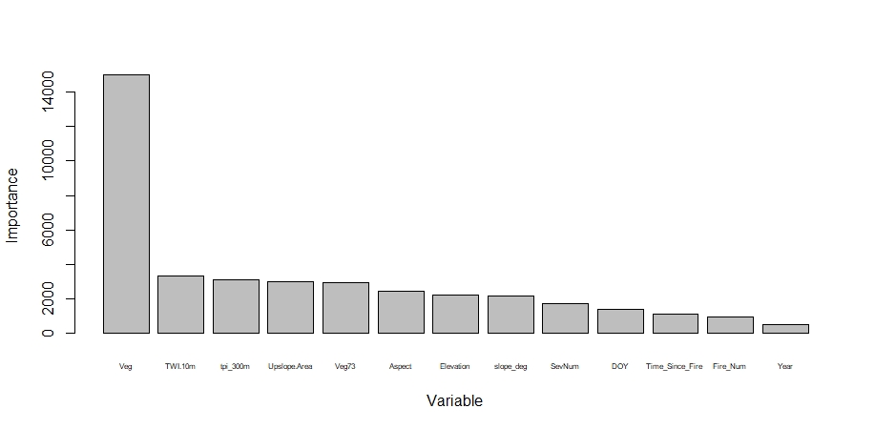

Figure 1. Relative importance of each variable in predicting plot-level soil moisture.

Similarly to the field-sampled soil moisture, continuous weather station records indicate that the wetland site is also associated with the highest soil moisture among all three stations. Figure 2 shows volumetric soil moisture time series for three soil depths (12, 60, and 100 cm) for [dense] wetland, shrub, and forest weather stations. For ICB results, refer to Appendix A.

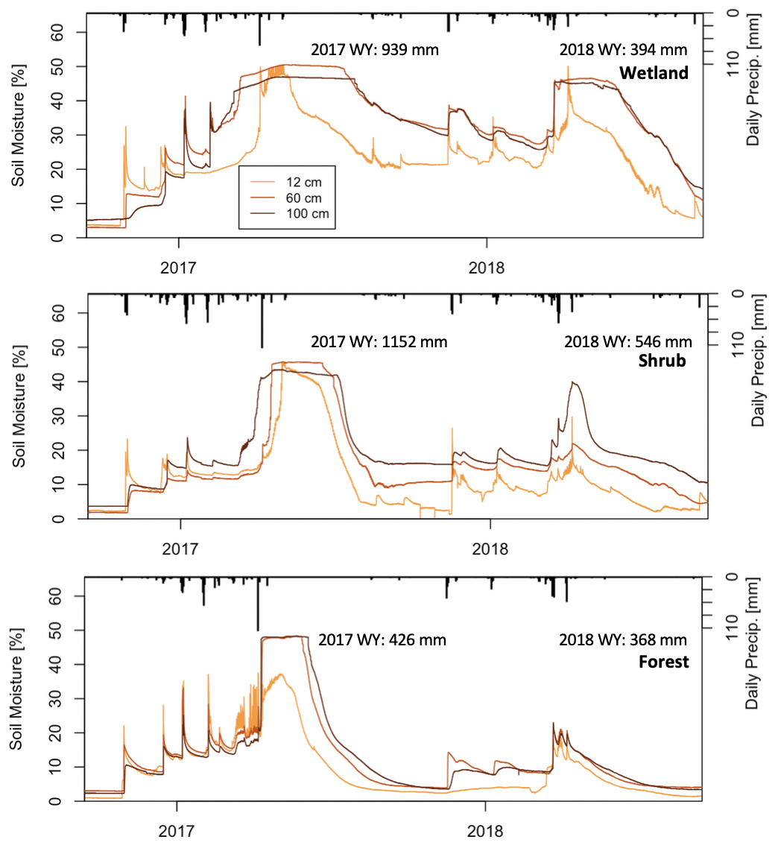Figure 2: volumetric water content [%] in shallow (12 cm), mid (60 cm), and deep (100 cm) soils as measured by wetland (top plot), shrub (middle plot), and forest (bottom plot) weather stations. Data was measured at 10 minute intervals for 2017 and 2018 water years. Daily precipitation in the form of rain and snow melt is presented as vertical bars. Water year (WY) summaries are also provided for total precipitation recorded at each station.

All three weather stations have experienced greater and more persistent soil moisture during the 2017 water year (WY) than the 2018 WY, as a result of large precipitation differences. Although precipitation totals are different across the stations and years, forest station measured the least amount of precipitation, likely due to interception. At the same time, forest station shows the greatest soil moisture difference between the two water years. During the 2017 WY, forest station has reached saturation for 56 days. However in the 2018 WY, soil moisture reached peak water content of 20% for a brief period before declining. Both wetland and shrub sites show differences in soil moisture between the different water years with declines in both the length of the saturation period and end of WY soil moisture. The three vegetation cover types are ranked in average soil moisture from highest to lowest as follows: wetland, shrub, followed by forest cover type.

Generally, deeper soils contain more water and stay saturated longer than shallow soils. For all three stations, shallow soil moisture is the most responsive to precipitation. Although precipitation and snow melt pulses are very apparent at 60 and 100 cm depths as well. From correlation analysis, shallow (12 cm) soil has a strong positive correlation to deep (100 cm) soil (See Table 1 for Pearson correlation coefficients).

[This would be a good place to tie Gabrielle’s random forest model if we decide to do so]

*Comparison to ICB*

Much of the completed work so far has focused on Illilouette Creek Basin, in Yosemite National Park (cite Gabrielle, Scott, and Brandon’s papers). In this section we compare climatic differences and consequent soil moisture responses across different vegetation types between the two basins.

On average, SCB is 0.3 degrees Celsius cooler in the summer and 0.2 degrees cooler in the winter than ICB with average summer temperatures of 15.7 degrees Celsius and average winter temperatures of -1.1 degrees Celsius (see Figure 3). In SCB, the forest station is on average 0.6 degrees warmer than the wetland station, and 0.1 degrees warmer than the shrub station. That difference is even greater in ICB where the forest station is on average 1.2 degrees warmer than the wetland station and 0.3 degrees warmer than the shrub station.



Figure 3: Mean monthly temperatures for SCB’s (top), and ICB’s (bottom) weather stations for 2017 and 2018 water years for forest, shrub, and wetland stations.

[Veg Change Analysis Difference]

[Field Measured Soil Moisture]

Differences in weather station vegetation between ICB and SCB do exist. The SCB wetland site contains larger portion of conifer regeneration in comparison to ICB which is predominantly vegetated with tall grasses. The shrubland site in ICB prior to the Empire Fire in the fall of 2017 was comprised mostly of white-thorn (*Ceanothus*). The fire burned the shrub site at high severity, resulting in bare soils with little live vegetation for the following 2018 WY. In comparison, the SCB shrub site contains a dense growth of young conifers with a mix of ceanothus. Forest sites are similar in tree density, tree species, and slope for both ICB and SCB

Summaries of precipitation and soil moisture from weather stations can be found in Table 1 for 2017 and 2018 WYs for both sites. Total precipitation in ICB is 1.1-2.0 times the total precipitation in SCB for the wet 2017 WY. For the drier 2018 WY, total precipitation in ICB is between 1.3-1.7 times precipitation in SCB. Precipitation totals for ICB are conservative for 2017 WY because of the removal of the weather stations prior to the Empire Fire (September through the end of November). There were at least two non-recorded precipitation events during the time the stations were non-operational.

~~Cumulative shallow soil moisture gain supports the fact that ICB gains more water than SCB. Although if the soil is saturated for longer periods, it is not possible to calculate water gain from soil moisture records.~~ Cumulative shallow soil moisture gain was calculated from depth and time integrated soil moisture timeseries. Cumulative soil moisture is another metric to gauge how much water shallow soils have received. It is a useful metric to approximate precipitation amounts when the tipping bucket record is missing or not reliable. Although in the case of saturated wetland sites, water gain cannot be calculated.

Table 1 also provides Pearson correlation coefficients, relating how much 12 cm soil moisture correlates to 100 cm soil moisture at weather stations between the months of June and September. This correlation is strong across most sites, years, and locations. Two big exceptions being ICB’s wetland site which retains saturated deep but not shallow soils in the summer, and SCB’s shrub site in the 2018 WY. The overall strong relationship between shallow and deep soil moisture provides additional confidence in the usefulness of our analysis of field collected soil moisture that only extended to 12 cm.

|  |  |  |  |  |  |  |  |  |  |  |  |
| --- | --- | --- | --- | --- | --- | --- | --- | --- | --- | --- | --- |
| Weather Station Vegetation Type | | Total precipitation [mm] | | Cumulative shallow soil water gain [mm] | | End of WY  VWC [%] | | Days Saturated at 100 cm | | Correlation coeff. between 12 & 100 cm VWC for Jun-Sept | |
| WY: | | 2017 | 2018 | 2017 | 2018 | 2017 | 2018 | 2017 | 2018 | 2017 | 2018 |
| SCB | Wetland | 939 | 394 | 473 | 469 | 34 | 14 | 155 | 81 | 0.88 | 0.94 |
| ICB | 1192 | 657 | 56 | 30 | 43 | 43 | 365* | 365 | 0.90 | 0.19 |
| SCB | Shrub | 1152 | 546 | 362 | 287 | 16 | 10 | 88 | 0 | 0.94 | 0.20 |
| ICB | 1287 | 713 | 940 | 378 | 10 | 5.6 | 86* | 0 | 0.87 | 0.87 |
| SCB | Forest | 426 | 368 | 834 | 184 | 4.7 | 3.4 | 56 | 0 | 0.99 | 0.97 |
| ICB | 840 | 508 | 776 | 334 | 3.5 | 3.4 | 31* | 0 | 0.90 | 0.86 |

* :Approximated due to missing data as a result of the Empire Fire

**Table 1**: Gap-filled precipitation totals measured by rain gauge; cumulative shallow soil water gains calculated from shallow soil moisture timeseries; end of the water year deep soil moisture and number of saturation days calculated from 100 cm soil moisture probe record. Pearson’s correlation coefficient calculated between 12 cm and 100 cm soils for months of June through September. Analysis was done for both SCB and ICB locations, and all three vegetation cover types represented by weather stations at each location.

For both ICB and SCB, majority of the precipitation is in the form of snow. Differences in snowpack depth between the three stations was observed (Figure 4). Sugarloaf has missing snow depth record due to cameras being covered with snow for much of the 2017 WY. However, it is clear that SCB had more snow that winter than ICB. Snow depth was comparable between the two sites during the 2018 WY. In ICB manual snow depth measurements were taken in a grid around each weather station either once or twice each winter [give exact dates] (Figure 4).in March 2016, January and April 2017, and March 2018 (Figure 4). For both locations and all water years, the wetland station on average had the greatest snow depth with the latest melt date, followed by the shrub station. Forest station had the lowest snowpack depth and earliest melt date.

**

Figure 4: Snow depth (in mm) for Sugarloaf Creek Basin (top) and Illilouette Creek Basin (bottom) as measured from images taken four times each day at wetland, shrub, and forest weather station sites. Additionally, error bars (squares indicating mean, and bars indicating standard deviation) are shown for manually measured snow depths in ICB.

[For the discussion section: Difference in vegetation types has implications on snowpack depth and melt timing which further influence seasonal soil moisture and vegetation species. Since fire regime can convert one vegetation type to another, fire has a role in snow dynamics across a watershed]

**Discussion**

This will be written once the analyses are complete and the core focus of the paper is agreed upon. All authors will contribute here.

**Figure 0**: Location/map figure



Figure 5:Change in forest structure based on forestry plots



Figure 6: Map of the imagery portion of the watershed, showing times burned. Will probably add the classified images from both years to this figure.



Figure 7: Image change analysis. Colors indicated change in observed vegetation transitions relative to a null expectation of equally likely change in each direction. Color scale the proportion of the null expectation that a given transition occurred, either more (blue) or less (red) than expected. Cell numbers indicate the number of 0.16 ha pixels in each transition category.



Figure 8: Average soil moisture by vegetation type and sampling date.

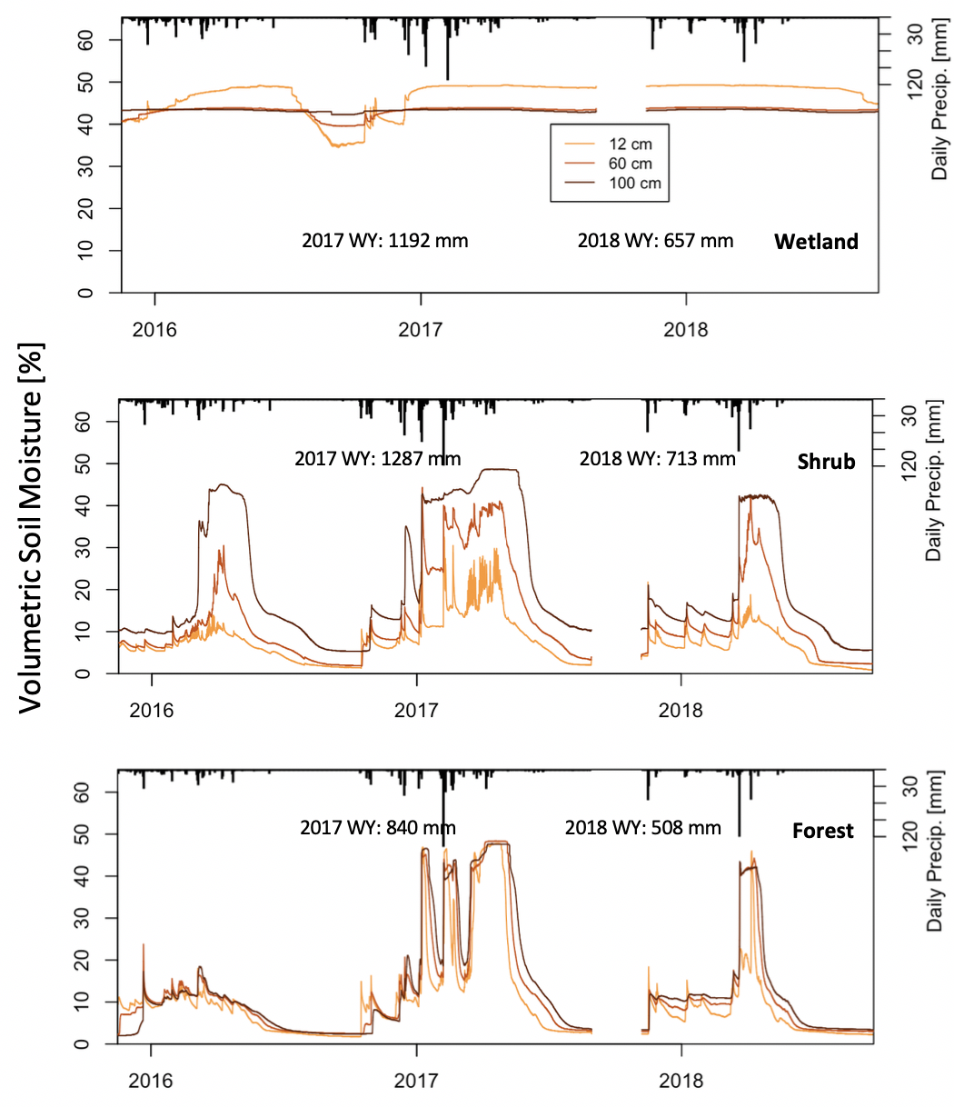

**Figure 6:** volumetric soil moisture [%] in shallow (12 cm), mid (60 cm), and deep (100 cm) soils as measured by wetland (top plot) , shrub (middle plot) , and forest (bottom plot) weather stations in Sugarloaf Creek Basin. Data was measured at 10 minute intervals for 2017 and 2018 water years. Daily precipitation in the form of rain and snow melt is presented as vertical bars. Water year (WY) summaries are also provided for total precipitation recorded at each station.

**Literature Cited**

Boisramé, G., S. Thompson, B. Collins, and S. Stephens. 2017a. Managed wildfire effects on forest resilience and water in the Sierra Nevada. Ecosystems **20**:717-732.

Boisramé, G., S. Thompson, and S. Stephens. 2018. Hydrologic responses to restored wildfire regimes revealed by soil moisture-vegetation relationships. Advances in Water Resources **112**:124-146.

Boisramé, G. F., S. E. Thompson, M. Kelly, J. Cavalli, K. M. Wilkin, and S. L. Stephens. 2017b. Vegetation change during 40years of repeated managed wildfires in the Sierra Nevada, California. Forest Ecology and Management **402**:241-252.

Boisramé, G. F. S., S. E. Thompson, M. Kelly, J. Cavalli, K. M. Wilkin, and S. L. Stephens. 2017c. Vegetation change during 40years of repeated managed wildfires in the Sierra Nevada, California. Forest Ecology and Management **402**:241-252.

Collins, B. M., R. G. Everett, and S. L. Stephens. 2011. Impacts of fire exclusion and recent managed fire on forest structure in old growth Sierra Nevada mixed‐conifer forests. Ecosphere **2**:1-14.

Collins, B. M., M. Kelly, J. W. van Wagtendonk, and S. L. J. L. E. Stephens. 2007. Spatial patterns of large natural fires in Sierra Nevada wilderness areas. **22**:545-557.

Collins, B. M., J. M. Lydersen, D. L. Fry, K. Wilkin, T. Moody, S. L. J. F. E. Stephens, and Management. 2016. Variability in vegetation and surface fuels across mixed-conifer-dominated landscapes with over 40 years of natural fire. **381**:74-83.

Collins, B. M., J. D. Miller, A. E. Thode, M. Kelly, J. W. Van Wagtendonk, and S. L. J. E. Stephens. 2009. Interactions among wildland fires in a long-established Sierra Nevada natural fire area. **12**:114-128.

Grant, G. E., C. L. Tague, and C. D. Allen. 2013. Watering the forest for the trees: an emerging priority for managing water in forest landscapes. Frontiers in Ecology and the Environment **11**:314-321.

Hijmans, R., and J. van Etten. 2014. raster: Geographic data analysis and modeling. R package version **517**:2.2-12.

McKelvey, K. S., C. N. Skinner, C.-r. Chang, D. C. Erman, S. J. Husari, D. J. Parsons, J. W. van Wagtendonk, and C. P. Weatherspoon. 1996. An overview of fire in the Sierra Nevada.*in* Pages 1033-1040 in: Sierra Nevada Ecosystem Project, Final Report to Congress, Vol. II, Assessments and Scientific Basis for Management Options. Davis, CA: University of California, Centers for Water and Wildland Resources. Report No. 37.

North, M., S. Stephens, B. Collins, J. Agee, G. Aplet, J. Franklin, and P. Fulé. 2015. Reform forest fire management. Science **349**:1280-1281.

Ponisio, L. C., K. Wilkin, L. K. M'gonigle, K. Kulhanek, L. Cook, R. Thorp, T. Griswold, and C. J. G. c. b. Kremen. 2016. Pyrodiversity begets plant–pollinator community diversity. **22**:1794-1808.

Stephens, S. L., J. K. Agee, P. Fulé, M. North, W. Romme, T. Swetnam, and M. G. Turner. 2013. Managing forests and fire in changing climates. Science **342**:41-42.

Stephens, S. L., B. M. Collins, E. Biber, and P. Z. Fulé. 2016. US federal fire and forest policy: emphasizing resilience in dry forests. Ecosphere **7**.

Westerling, A. L., and T. W. Swetnam. 2003. Interannual to decadal drought and wildfire in the western United States. EOS, Transactions American Geophysical Union **84**:545-555.

Appendix A

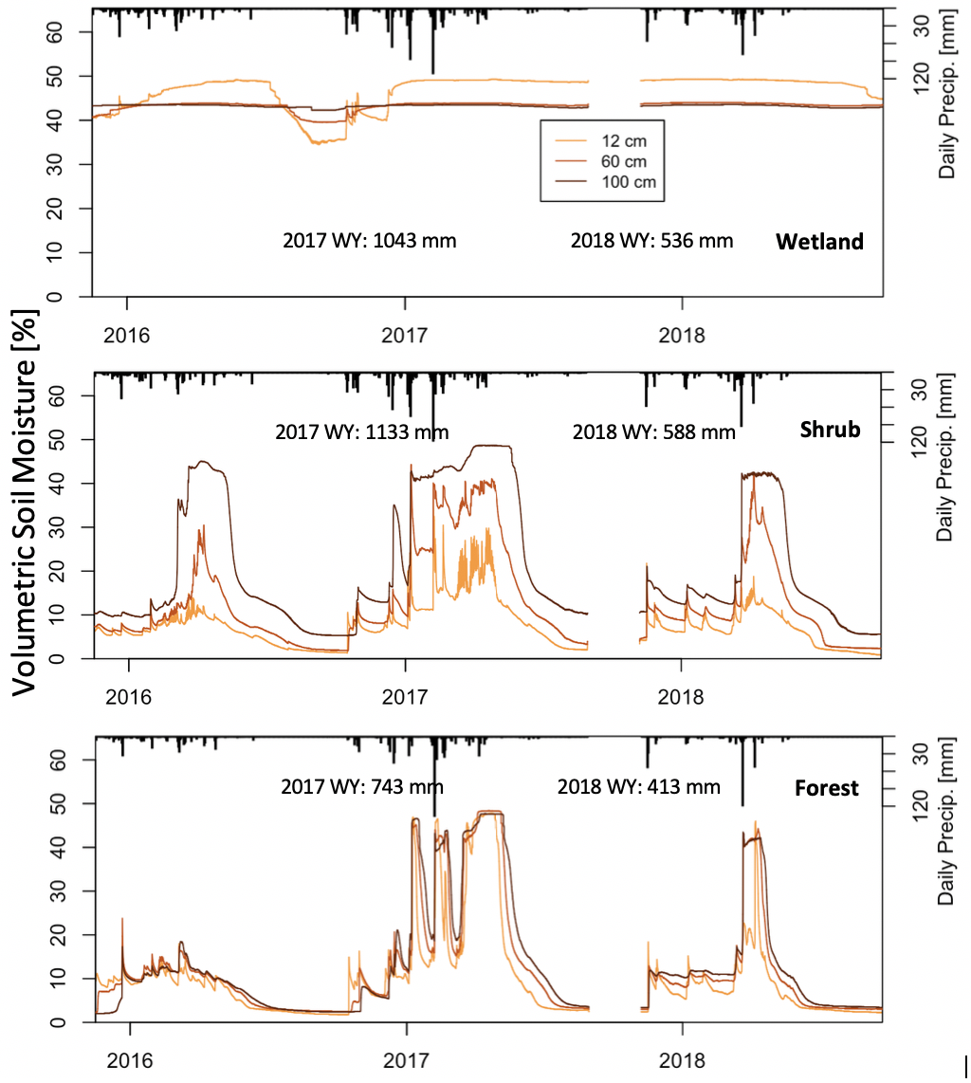

Figure A.1: volumetric soil moisture [%] in shallow (12 cm), mid (60 cm), and deep (100 cm) soils as measured by wetland (top plot) , shrub (middle plot) , and forest (bottom plot) weather stations in Illilouette Creek Basin. Data was measured at 10 minute intervals for part of 2016, 2017 and 2018 water years. Daily precipitation in the form of rain and snow melt is presented as vertical bars. Water year (WY) summaries are also provided for total precipitation recorded at each station. The Empire fire has burned through the area where the stations were installed, resulting in the prior removal of the station and lack of data for the month of October and November 2017.

Appendix B: Precipitation Gap Filling

The first step in obtaining accurate precipitation timeseries was to remove all incorrect precipitation records. This includes times when the rain gauge is upside down or damaged in any other visible way, or when false precipitation measurements are clearly caused by a person or animal moving the gauge (e.g., when maintenance occurred or when time lapse cameras show that an animal disturbed the station). The next step was to set precipitation record as missing for the times when the station recorded zero precipitation, but the surrounding stations have recorded a precipitation event and there was a pulse in shallow soil moisture content. This type of missing data has mostly occurred in the winter months when the tipping bucket was likely to be frozen and/or the rain gauge was covered with snow. After this step, in Sugarloaf Creek Basin, 32% of precipitation at the forest, 25% at the shrub, and 27% at the wetland station was missing. In Illilouette Creek Basin, these percentages were: 24%, 10%, and 19% respectively.

If all three stations were missing precipitation record, then a combination of snow melt amounts and shallow soil water inputs was used to gap-fill the record (Figure B.1). Snow melt depth was converted to water equivalent using density of 0.4. Shallow soil water inputs were estimated by smoothing 10-min soil moisture content at the depth of 12 cm, and then depth integrating moisture content over the time series. Positive change was counted as water accumulation, and negative change was counted as water loss. While shallow soil water input metric is not a good approximation for the precipitation amount, it is a good metric to detect precipitation and melt events in the absence of rain gauge data.

In the final step, a Bayesian linear regression model (mice.impute.norm function in R package “MICE”) was used to impute missing data when there was record for at least one station. All predictions were rounded to the nearest 0.1 inch (0.254 mm), since that is the smallest measurement detected by the rain gauge

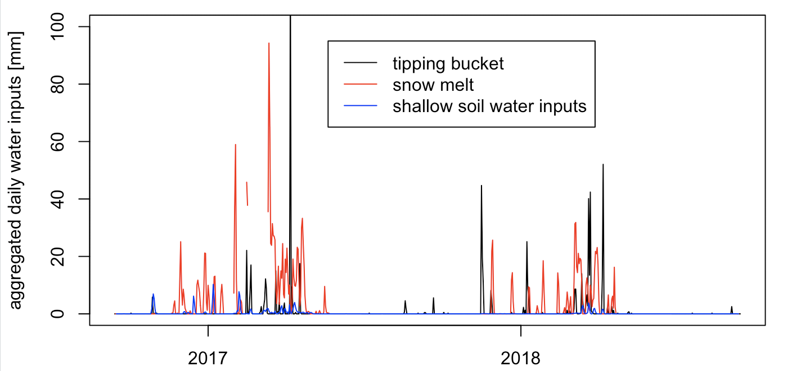

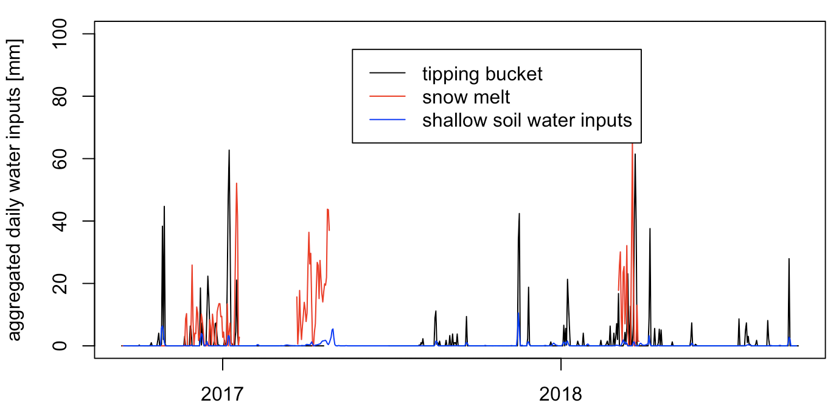

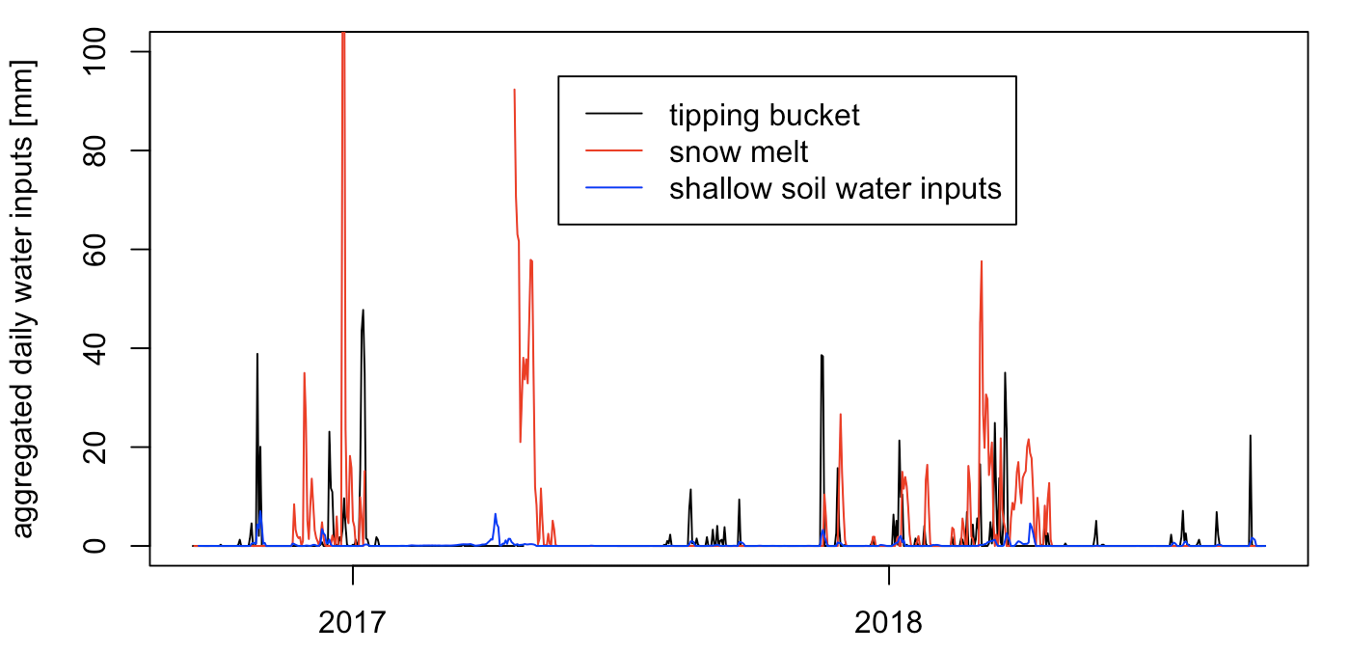

Figure B.1: Forest (top), shrub (middle), wetland (bottom)